Producer Consumer using queue

#include <stdio.h>
#include <stdlib.h>
#include <semaphore.h>

#define BUFFER_SIZE 5

int buffer[BUFFER_SIZE];
int front = -1, rear = -1;

sem_t empty, full, mutex;

void producer() {
int item;

if ((rear + 1) % BUFFER_SIZE == front) {
printf("Buffer is FULL! Cannot produce.\n");
return;
}

printf("Enter item to produce: ");
scanf("%d", &item);

sem_wait(&empty);
sem_wait(&mutex);

if (front == -1) front = 0;
rear = (rear + 1) % BUFFER_SIZE;
buffer[rear] = item;

printf("Produced %d at position %d\n", item, rear);

sem_post(&mutex);
sem_post(&full);
}

void consumer() {
int item;

if (front == -1) {
printf("Buffer is EMPTY! Cannot consume.\n");
return;
}

sem_wait(&full);
sem_wait(&mutex);

item = buffer[front];
printf("Consumed %d from position %d\n", item, front);

if (front == rear) {
front = rear = -1;
} else {
front = (front + 1) % BUFFER_SIZE;
}

sem_post(&mutex);
sem_post(&empty);
}

int main() {
int choice;

sem_init(&empty, 0, BUFFER_SIZE);
sem_init(&full, 0, 0);
sem_init(&mutex, 0, 1);

printf("Enter ");
printf("1. Producer ");
printf("2. Consumer ");
printf("3. Exit\n");

while (1) {
printf("\nEnter choice: ");
scanf("%d", &choice);

switch (choice) {
case 1:
producer();
break;
case 2:
consumer();
break;
case 3:
printf("Exiting...\n");
sem_destroy(&empty);
sem_destroy(&full);
sem_destroy(&mutex);
exit(0);
default:
printf("Invalid choice!\n");
}
}

return 0;
}

OUTPUT
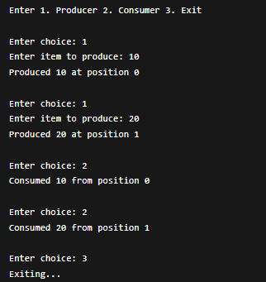

Producer Consumer Using Semaphore
#include <stdio.h>
#include <pthread.h>
#include <unistd.h>
#include <semaphore.h>

#define BUFFER_SIZE 5
#define NUM_PRODUCERS 2
#define NUM_CONSUMERS 2

int buffer[BUFFER_SIZE];
int in = 0, out = 0;

sem_t empty;
sem_t full;
pthread_mutex_t mutex;

void* producer(void* arg) {
int id = *(int*)arg;
int item = 0;

while (1) {
item++;

sem_wait(&empty);
pthread_mutex_lock(&mutex);

buffer[in] = item;
printf("Producer %d produced %d at buffer[%d]\n", id, item, in);
in = (in + 1) % BUFFER_SIZE;

pthread_mutex_unlock(&mutex);
sem_post(&full);

sleep(1);
}
}

void* consumer(void* arg) {
int id = *(int*)arg;
int item;

while (1) {
sem_wait(&full);
pthread_mutex_lock(&mutex);

item = buffer[out];
printf("Consumer %d consumed %d from buffer[%d]\n", id, item, out);
out = (out + 1) % BUFFER_SIZE;

pthread_mutex_unlock(&mutex);
sem_post(&empty);

sleep(2);
}
}

int main() {
pthread_t prod[NUM_PRODUCERS], cons[NUM_CONSUMERS];
int p_id[NUM_PRODUCERS], c_id[NUM_CONSUMERS];

sem_init(&empty, 0, BUFFER_SIZE);
sem_init(&full, 0, 0);
pthread_mutex_init(&mutex, NULL);

for (int i = 0; i < NUM_PRODUCERS; i++) {
p_id[i] = i + 1;
pthread_create(&prod[i], NULL, producer, &p_id[i]);
}

for (int i = 0; i < NUM_CONSUMERS; i++) {
c_id[i] = i + 1;
pthread_create(&cons[i], NULL, consumer, &c_id[i]);
}

for (int i = 0; i < NUM_PRODUCERS; i++)
pthread_join(prod[i], NULL);

for (int i = 0; i < NUM_CONSUMERS; i++)
pthread_join(cons[i], NULL);

sem_destroy(&empty);
sem_destroy(&full);
pthread_mutex_destroy(&mutex);

return 0;
}

OUTPUT
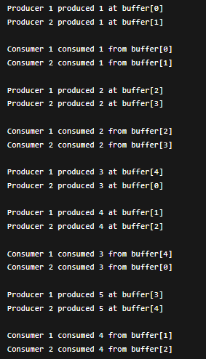

Dining Philosopher
#include <stdio.h>
#include <pthread.h>
#include <unistd.h>

#define N 5 // Number of philosophers

pthread_mutex_t forks[N]; // One mutex per fork
pthread_t philosophers[N];

void* philosopher(void* num)
{
int id = *(int*)num;
int left = id;
int right = (id + 1) % N;

while (1)
{
printf("Philosopher %d is thinking.\n", id);
sleep(1);

if (id % 2 == 0)
{
pthread_mutex_lock(&forks[left]);
printf("Philosopher %d picked up left fork %d.\n", id, left);

pthread_mutex_lock(&forks[right]);
printf("Philosopher %d picked up right fork %d.\n", id, right);
}
else
{

pthread_mutex_lock(&forks[right]);
printf("Philosopher %d picked up right fork %d.\n", id, right);

pthread_mutex_lock(&forks[left]); // FIXED LINE
printf("Philosopher %d picked up left fork %d.\n", id, left);
}

printf("Philosopher %d is eating.\n", id);
sleep(2);

pthread_mutex_unlock(&forks[left]);
pthread_mutex_unlock(&forks[right]);

printf("Philosopher %d put down forks %d and %d.\n", id, left, right);
}

return NULL;
}

int main()
{
int i;
int ids[N];

for (i = 0; i < N; i++)
{
pthread_mutex_init(&forks[i], NULL);
ids[i] = i;
}

for (i = 0; i < N; i++)
{
pthread_create(&philosophers[i], NULL, philosopher, &ids[i]);
}

for (i = 0; i < N; i++)
{
pthread_join(philosophers[i], NULL);
}

for (i = 0; i < N; i++)
{
pthread_mutex_destroy(&forks[i]);
}

return 0;
}

OUTPUT

